**JOBSHEET 14 ( GUI lanjutan )**

Latihan 1

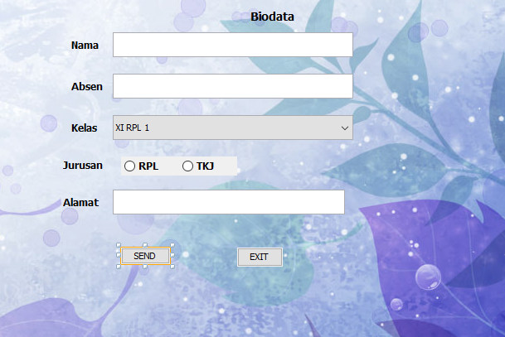

private void jButton1ActionPerformed(java.awt.event.ActionEvent evt) {

String nama = Nama.getText();

String absen = Absen.getText();

String kelas = Kelas.getSelectedItem().toString();

String jurusan = "";

String alamat = Alamat.getText();

if (rdb1.isSelected())

jurusan = "RPL";

else if (rdb2.isSelected())

jurusan = "TKJ";

else

jurusan = "";

if (Kelas.getSelectedItem()== "XI RPL 1"){

}

if (Kelas.getSelectedItem()== "XI RPL 2"){

}

if (Kelas.getSelectedItem()== "XI RPL 3"){

}

if (Kelas.getSelectedItem()== "XI RPL 4"){

}

if (Kelas.getSelectedItem()== "XI RPL 5"){

}

if (Kelas.getSelectedItem()== "XI RPL 6"){

}

if (Kelas.getSelectedItem()== "X RPL 1"){

}

if (Kelas.getSelectedItem()== "X RPL 2"){

}

if (Kelas.getSelectedItem()== "X RPL 3"){

}

if (Kelas.getSelectedItem()== "X RPL 4"){

}

if (Kelas.getSelectedItem()== "X RPL 5"){

}

if (Kelas.getSelectedItem()== "X RPL 6"){

}

if (Kelas.getSelectedItem()== "X RPL 7"){

}

if (Kelas.getSelectedItem()== "X TKJ 1"){

}

if (Kelas.getSelectedItem()== "X TKJ 2"){

}

if (Kelas.getSelectedItem()== "X TKJ 3"){

}

if (Kelas.getSelectedItem()== "X TKJ 4"){

}

if (Kelas.getSelectedItem()== "X TKJ 5"){

}

if (Kelas.getSelectedItem()== "X TKJ 6"){

Latihan2 kirim = new Latihan2();

kirim.setVisible(false);

kirim.Hasil1.setText(nama);

kirim.Hasil2.setText(absen);

kirim.Hasil3.setText(kelas);

kirim.Hasil4.setText(jurusan);

kirim.Hasil5.setText(alamat);

Latihan 2

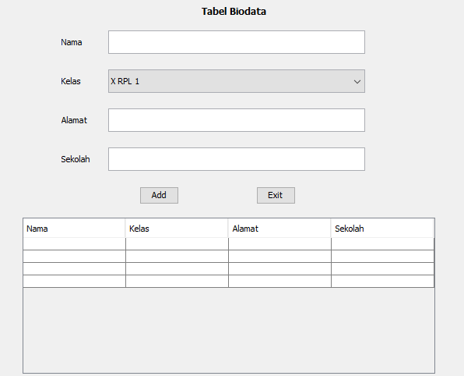

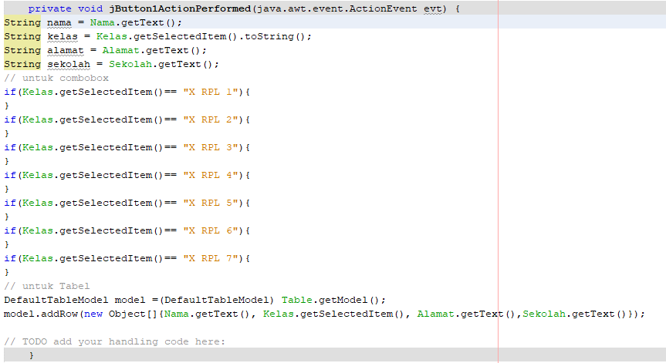

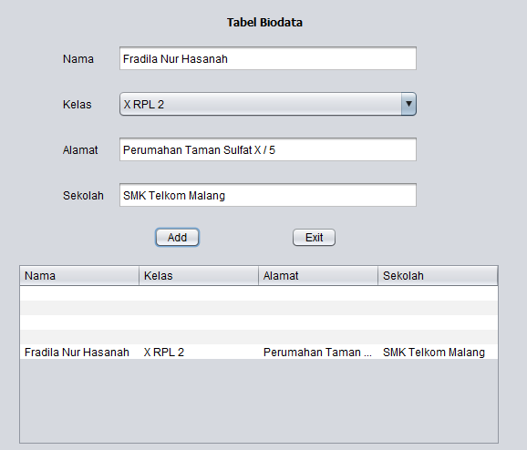

Latihan 3

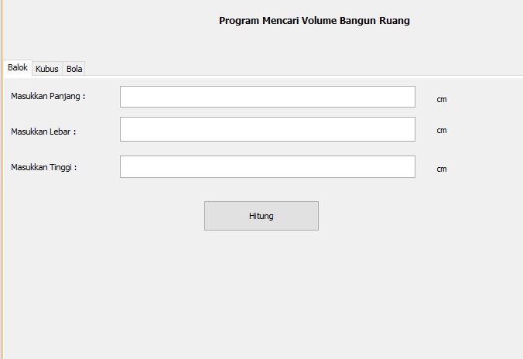

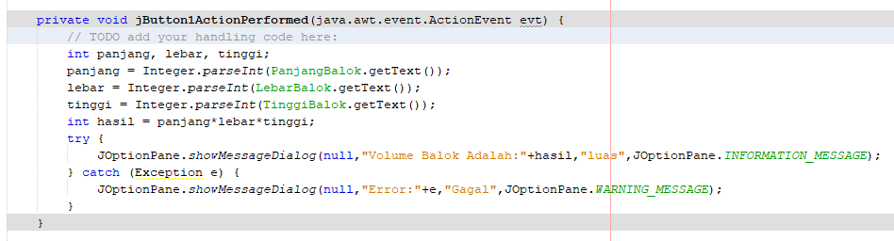

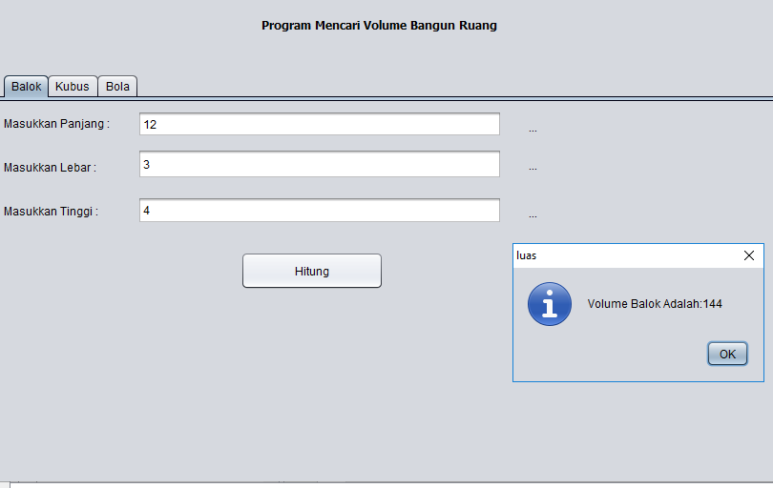

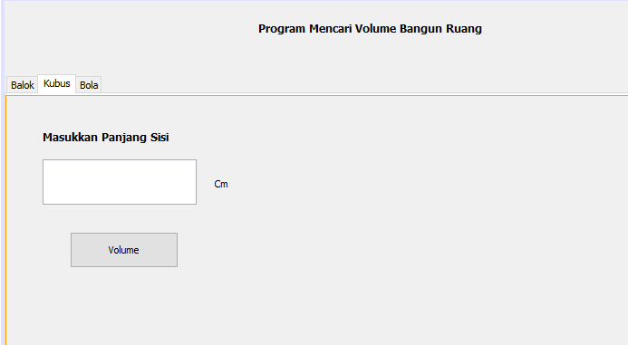

private void jButton2ActionPerformed(java.awt.event.ActionEvent evt) {

// TODO add your handling code here:

int sisi;

sisi = Integer.parseInt(SisiKubus.getText());

int hasil = sisi*sisi*sisi;

try{

JOptionPane.showMessageDialog(null,"Luas Permukaan Kubus Adalah :"+hasil,"luas",JOptionPane.INFORMATION_MESSAGE);

} catch (Exception e) {

JOptionPane.showMessageDialog(null,"Error:"+e,"Gagal",JOptionPane.WARNING_MESSAGE);

}

}

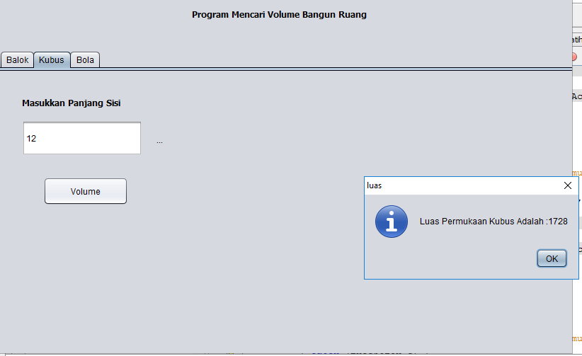

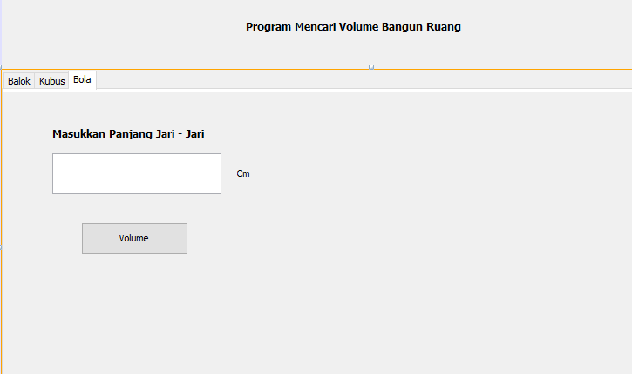

private void jButton3ActionPerformed(java.awt.event.ActionEvent evt) {

// TODO add your handling code here:

float jari;

jari = Integer.parseInt(JariBola.getText());

float hasil1=(float) (4/3*3.14*jari*jari*jari);

try {

JOptionPane.showMessageDialog(null,"Luas Permukaan Bola Adalah :"+hasil1,"Luas",JOptionPane.INFORMATION_MESSAGE);

} catch (Exception e) {

JOptionPane.showMessageDialog(null,"Error:"+e,"Gagal",JOptionPane.WARNING_MESSAGE);

}

}

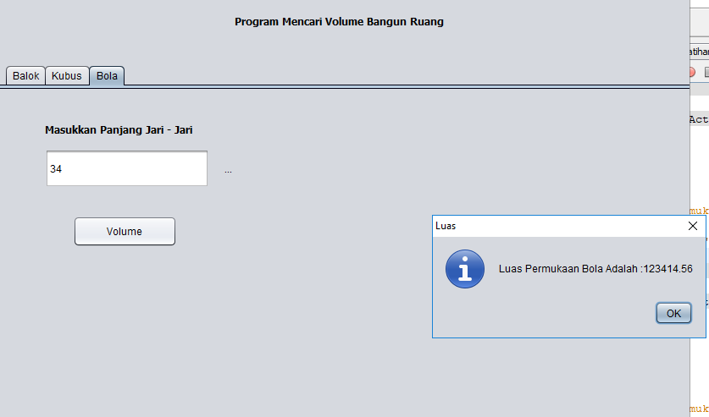

Tugas

